Echelon Masonry Continuing Education Lunch Programs

All programs AIA/ CES with 1 Learning Unit

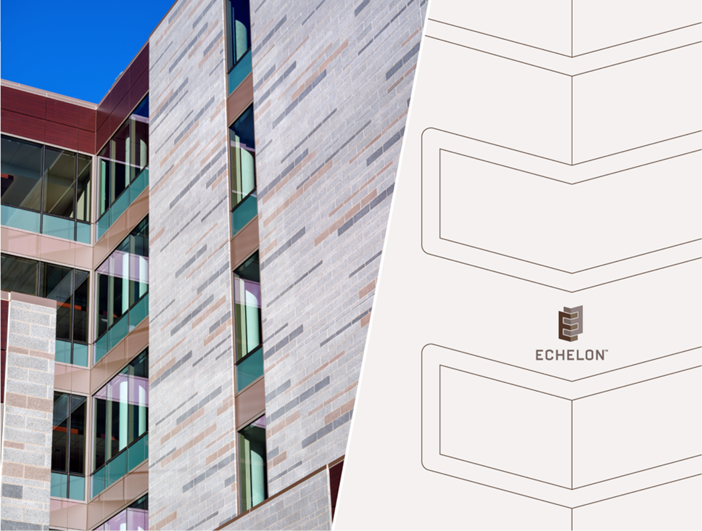

**Jack Chambers**

**Architectural Sales Representative**

Oldcastle APG / Echelon Masonry

Cell: 224-575-1425

One Hunt Court Mundelein, IL 60060 | 224-575-1425

[Jack.Chambers@oldcastle.com](mailto:Jean.Telander@oldcastle.com)

[www.echelonmasonry.com](http://www.echelonmasonry.com)

**Designing with Innovative Architectural Blocks for Buildings**

**• Program #: OSKA-02**

**• Provider #: J-374**

**• CEU’s: 1 HSW**

Concrete blocks are not just for foundations and basements. Architectural masonry units are animating the facades of schools, supporting columns of healthcare facilities and gracing the arches of shopping malls. This program will cover the vast range of masonry units available and their potential uses. Designing and building masonry structures to look good for the life of the building requires a fundamental understanding of the enemies of masonry and proper detailing to protect your walls. This discussion on critical detailing and project management will ensure lasting beauty of masonry units.

Design Tactics for Stone Masonry Products

* **Program #: TREN-10**
* **Provider #: J-374**
* **CEU’s 1 HSW**

This one-hour HSW program will explore how to effectively design masonry walls using proper design techniques focusing on the prevention of moisture, cracking and cleaning issues. This building design focus is on planning and designing sound masonry walls using proper architectural structural components based on industry guidelines and specifications. Attendees will learn why walls crack and how to design to eliminate unnecessary repairing and cleaning of masonry walls.

Designing with Masonry Units for a Healthier, Safer Building Environment (HSW)

* [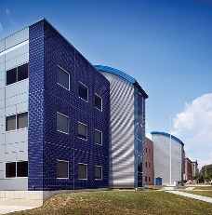](http://www.echelonmasonry.com/trenwyth-masonry/astra-glaze-sw-glazed-masonry-units)[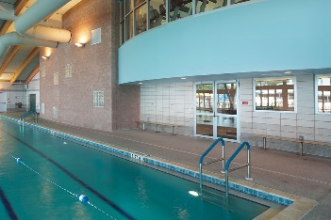](http://www.echelonmasonry.com/trenwyth-masonry/verastone-plus)**Program #: TREN-03**
* **Provider: J-374**
* **CEU’s: 1 HSW**

Concrete masonry is an effective solution for the ever-changing design environment. In this HSW program, the importance of test reports and their relevance to design and sound construction of the building envelope is explained. This program also addresses how good masonry practices can assist designers in achieving the objectives of Green Building and Sustainable Design. Also addressed are the proper techniques to create effective results with building acoustics, the importance of Fire Ratings and the impact on public safety. This presentation meets the AIA requirements for a one-hour Health, Safety and Welfare credit.

Virtual Concrete Products Plant Tour

* **Program #: ECH-CPPT**
* **Provider #: J-374**
* **CEU’s 1 HSW**

Concrete masonry is an effective solution for the ever-changing design environment. Buildings and structures with resilient design and materials are not only better able to withstand and recover following disasters such as hurricanes and tornadoes, products such as concrete and masonry are durable, environmentally friendly and use less embodied energy. This course reviews the quality control practices and procedures of manufactured concrete products. During the virtual plant tour, attendees will follow the steps from the arrival of the aggregates, to the initial mixing stages and then will continue through the facility to demonstrate the final steps of the production process. Moreover, the tour will address the proper manufacturing techniques needed in order to meet the required fire resistance, energy efficiencies and overall sustainable qualities of CMU’s. The tour will ultimately validate how concrete masonry products contribute to the health, safety and welfare of the people.